**Panel In Bootstrap**

**Panel Heading:**

The .panel-heading class adds a heading to the panel:

Example:

<!DOCTYPE html>

<html lang="en">

<head>

<title>Bootstrap Example</title>

<meta charset="utf-8">

<meta name="viewport" content="width=device-width, initial-scale=1">

<link rel="stylesheet" href="https://maxcdn.bootstrapcdn.com/bootstrap/3.4.1/css/bootstrap.min.css">

<script src="https://ajax.googleapis.com/ajax/libs/jquery/3.5.1/jquery.min.js"></script>

<script src="https://maxcdn.bootstrapcdn.com/bootstrap/3.4.1/js/bootstrap.min.js"></script>

</head>

<body>

<div class="container">

<h2>Panel Heading</h2>

<div class="panel panel-default">

<div class="panel-heading">Panel Heading</div>

<div class="panel-body">Panel Content</div>

</div>

</div>

</body>

</html>

Output:

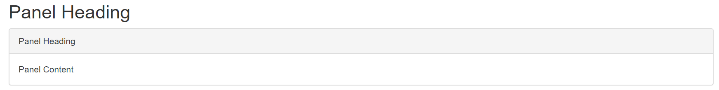

**Panel Footer:**

The .panel-footer class adds a footer to the panel:

Example:

<div class="panel panel-default">  
  <div class="panel-body">Panel Content</div>  
  <div class="panel-footer">Panel Footer</div>  
</div>

Output:-



**Panel Group:**

o group many panels together, wrap a <div> with class .panel-group around them.

The .panel-group class clears the bottom-margin of each panel:

Example:

<div class="panel-group">  
  <div class="panel panel-default">  
    <div class="panel-body">Panel Content</div>  
  </div>  
  <div class="panel panel-default">  
    <div class="panel-body">Panel Content</div>  
  </div>  
</div>

Output:

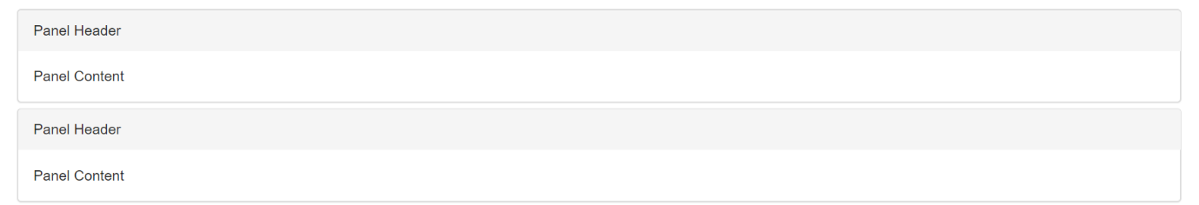

**Panels with Contextual Classes**

To color the panel, use contextual classes (.panel-default, .panel-primary, .panel-success, .panel-info, .panel-warning, or .panel-danger):

Example:

<div class="panel-group">

<div class="panel panel-default">

<div class="panel-heading">Panel with panel-default class</div>

<div class="panel-body">Panel Content</div>

</div>

<div class="panel panel-primary">

<div class="panel-heading">Panel with panel-primary class</div>

<div class="panel-body">Panel Content</div>

</div>

<div class="panel panel-success">

<div class="panel-heading">Panel with panel-success class</div>

<div class="panel-body">Panel Content</div>

</div>

<div class="panel panel-info">

<div class="panel-heading">Panel with panel-info class</div>

<div class="panel-body">Panel Content</div>

</div>

<div class="panel panel-warning">

<div class="panel-heading">Panel with panel-warning class</div>

<div class="panel-body">Panel Content</div>

</div>

<div class="panel panel-danger">

<div class="panel-heading">Panel with panel-danger class</div>

<div class="panel-body">Panel Content</div>

</div>

</div>

Output:

